OBJECTIVES
To evaluate the structural behaviour and damping response of a shock absorber assembly by using three different materials: Magnesium, Steel, and aluminum under simulated dynamic condition was the primary objective. Others were:
- To observe the stress distribution, deformation, strain capabilities of each component.
- To validate the assembled shock absorber’s ability to perform efficiently under repetitive loading without mechanical failure.

PERSONAL ENGINEERING ACTIVITIES
I decided to compare the structural ad damping performance of the shock absorber using various materials: aluminum, magnesium and steel (structural). I first selected aluminum alloy for its strong corrosion resistance and optimal strength-to-weight ratio making it a practical choice for moderate load applications requiring a balance between weight and durability. Next, I chose magnesium alloy due to its exceptionally low density which is very advantageous for lightweight design where reducing inertia is critical. Finally, I decide to choose structural steel because of its high strength, rigidity and reliability in maximum stress conditions. I designed the 3D model of shock absorber assembly using SolidWorks and exported in IGES format in ANSYS to perform simulations under defined boundary conditions.
Table 1: Mechanical Behavior of Selected Materials
Property | Magnesium Alloy | Structural Steel | Aluminum Alloy
Density (kg/ $m^{3})$ | 1780 | 7850 | 2700
Modulus of elasticity (GPa) | 45 | 200 | 69
Yield Strength (MPa) | 160 | 250 | 275
Ultimate Tensile Strength (MPa) | 250 | 400 | 310
Poisson's Ratio | 0.35 | 0.29 | 0.33

After selecting the materials, I performed design calculations to estimate the performance such as stiffness of spring and damping force. I understood how the shock absorber would respond under dynamic loading conditions specially during vehicle motion over uneven surfaces.
For the purpose of calculation, I considered a vehicle of mass 300 kg supported by four shock absorbers and assumed a maximum vertical displacement of 50 mm during impact.
Given:
Total mass of vehicle, M = 300 kg
Mass supported per shock absorber, m = M / 4 = 75 kg
Acceleration of gravity, g = 9.81 m/s²
Max. compression (displacement), x = 0.05 m
I calculated the spring force using Hooke's Law:
F = m × g = k × x
⇒ k = (m × g) / x
= (75 × 9.81) / 0.05
= 7357.5 N/m
Thus, the spring stiffness required was approximately 7358 N/m.
Next, I estimated the damping force using the basic damping force equation:
F d = c × v
where c is the coefficient of damping and v is the movement of piston’s velocity. I assumed a damping coefficient c = 1200 Ns/m and piston velocity v = 0.3 m/s:
F d = 1200 × 0.3 = 360 N
I got to know from these calculations that it helped to analyse the basic response characteristics of the shock absorber and served as initial input parameters for modelling and simulation, making sure that the design provided adequate ride comfort and energy dissipation under real-world loading conditions.
I started by designing the base of the shock absorber using the circular and extrude features in SolidWorks. I set the outer diameter to approximately 40 mm and the width to 20 mm. I modelled the piston rod with a dia. of 12 mm and a width of 120 mm. I moved forward to create the coil spring by using a helical sweep feature. I made outer diameter of 35 mm, wire thickness of 6 mm, and a free length of 100 mm. I adjusted the number of turns to about 7 for realistic spring compression. I designed the threaded cylinder with grooves to house the spring and allowed vertical movement. Also, I constructed the lock nuts separately using the polygon and cut-extrude features, each about 45 mm in diameter and 10 mm thick. After creating all components, I used the assembly environment in SolidWorks to apply mate constraints. Once the full assembly was finalized, I exported in IGES for simulation. In ANSYS Workbench, I imported the IGES file to perform static structural analysis. I selected structural steel as the base material to analyse initial stress and deformation behaviour. For meshing, I used the automatic method and refined the mesh using the body sizing feature and limited the maximum element size to 6 mm. I verified mesh quality by checking skewness and element aspect ratio. Then I ran the simulation process and obtained key results such as stress distribution, deformation, and strain on different components of the shock absorber under load. I observed the behaviour of the spring and rod, confirming the mechanical integrity of the selected design and materials.

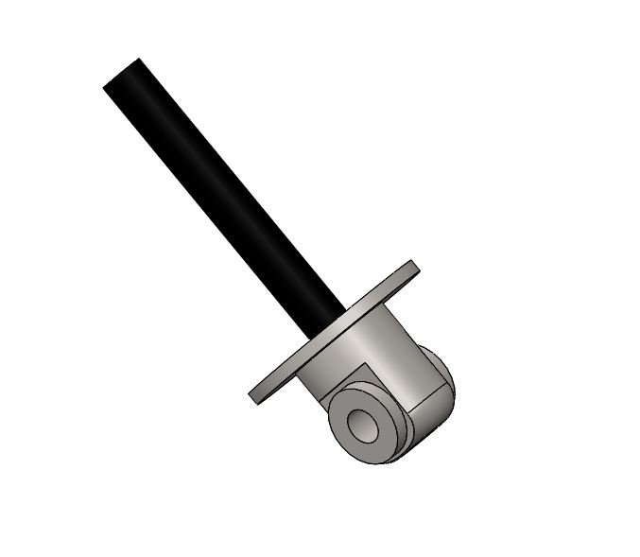
Figure 2: Base Rod in 3D view
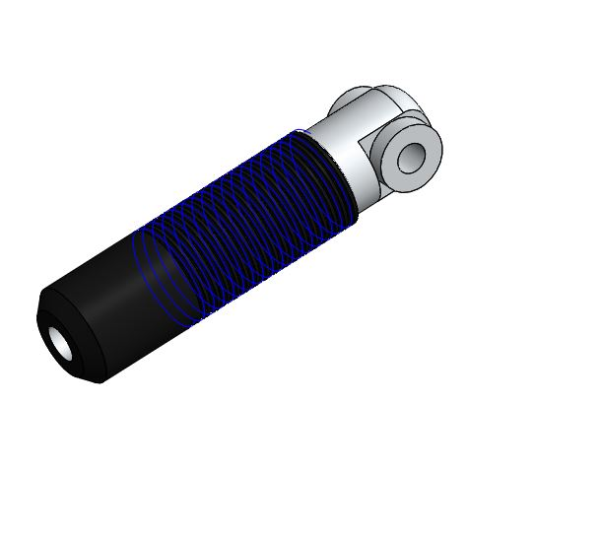
Figure 3:Top Rod in 3D view
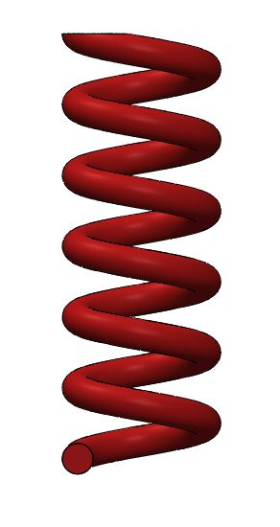
Figure 4: Helical Coil Spring in 3D view
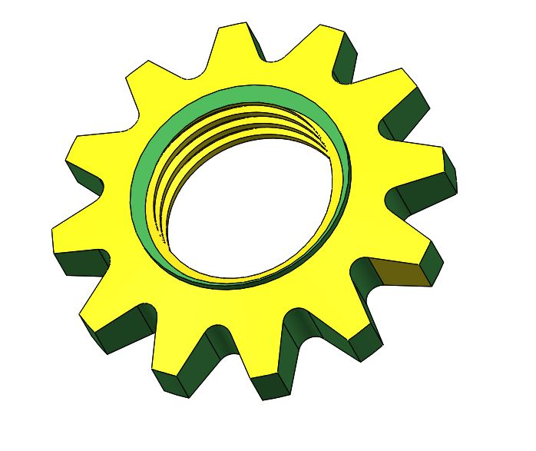
Figure 5: Nut in 3D view
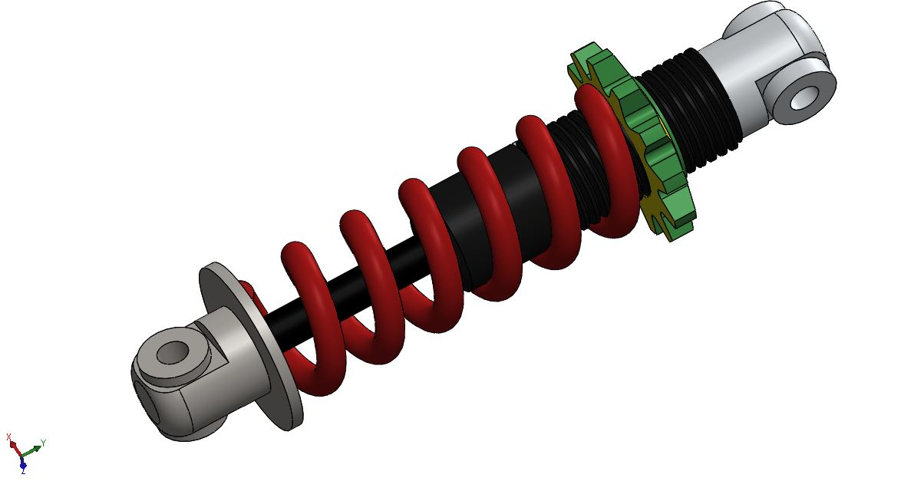
Figure 6: Finalized Shock Absorber Assy. in 3D View
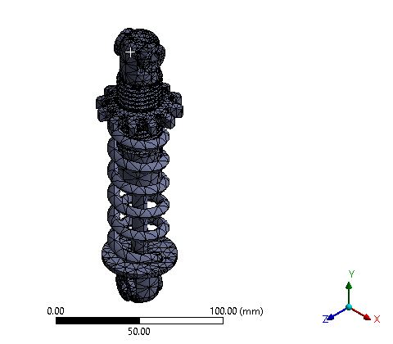
Figure 7: Meshing used on model
I ran the structural analysis on the shock absorber using ANSYS to examine performance of three different materials under static loading conditions. For the aluminum model, I measured a peak def. of 0.15147 mm, a maximum strain of 0.0030599 mm/mm and a stress peak of 216.69 MPa. With the magnesium alloy, I noted down the greater deformation at 0.23847 mm, a higher maximum strain of 0.0047239 mm/mm, and a marginally lower stress of 212.02 MPa. In contrast, I observed the structural steel model exhibited the lowest deformation at 0.053923 mm, a maximum strain of 0.0011208 mm/mm, and the highest stress value of 223.56 MPa. From all these findings, I observed that magnesium displayed the Highest def. and strain, which indicated least stiff and stable under load. I found out that aluminum alloy demonstrated moderate performance with balanced deformation and strain with weaker stress resistance. However, I noted that structural steel exhibited the lowest def. and strain maintaining the highest stress capacity clearly showing its superior rigidity and structural integrity. After seeing all these performance metrics, I concluded that structural steel is the optimal material for the shock absorber because of its strongest combination of strength, stability and minimal deformation which made it suited for withstanding high impact loads and ensured long term durability in practical applications.

Table 2: Static Structural Simulation Results
Material | Max. Def (mm) | Strain (Max.) (mm/mm) | Stress (Max.) (MPa)
Aluminum Alloy | 0.15147 | 0.0030599 | 216.69
Str. Steel | 0.053923 | 0.0011208 | 223.56
Magnesium Alloy | 0.23847 | 0.0047239 | 212.02

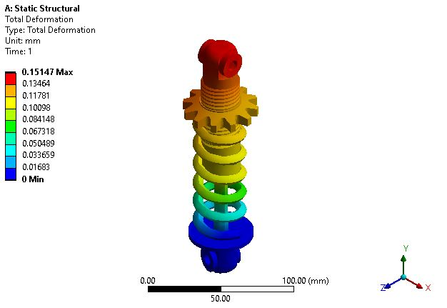
Fig 8: Def. Profile – Aluminum

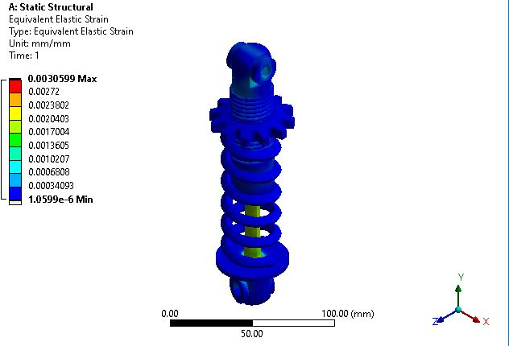
Fig 9: Strain Profile – Aluminum
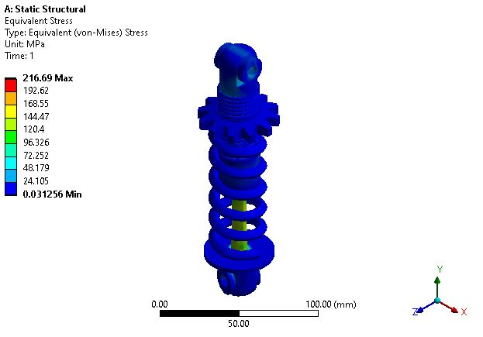
Fig 10: Stress Profile – Aluminum
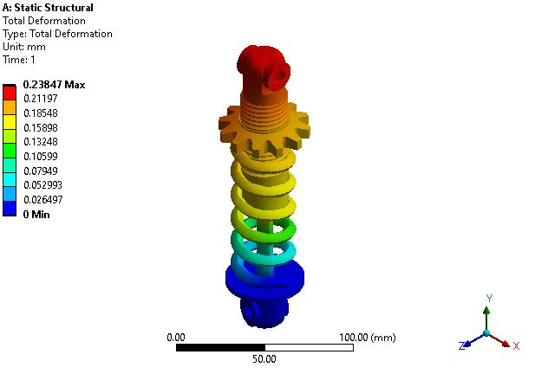
Fig 11: Def in Magnesium

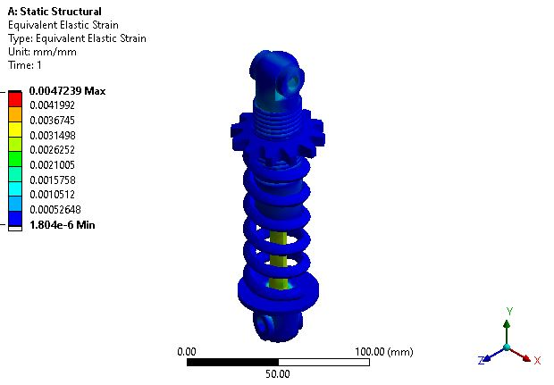
Fig 12: Strain in Magnesium
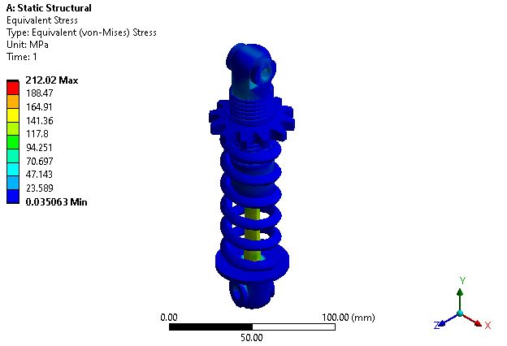
Fig 13: Stress in Magnesium

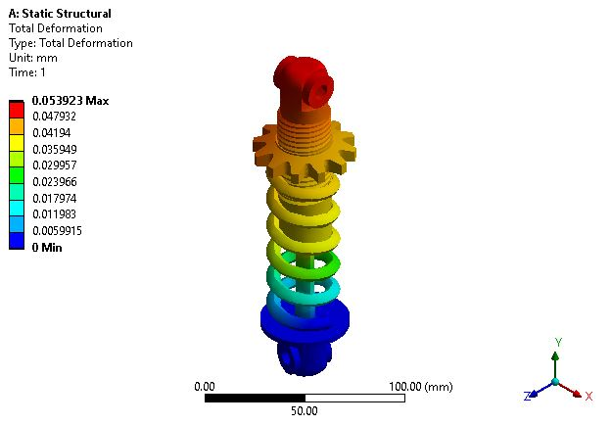
Fig 14: Showing Def. in Steel (Structural)
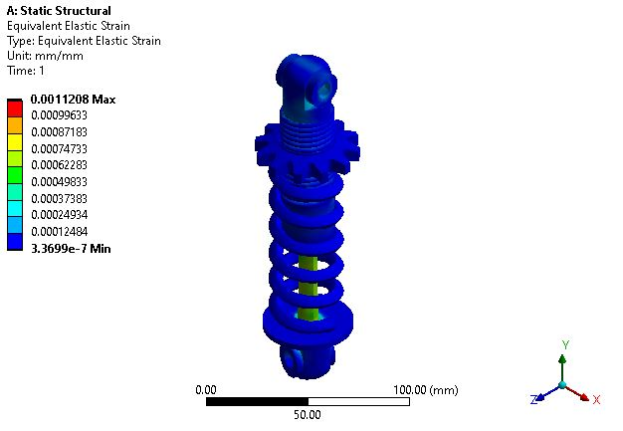
Fig 15: Showing Strain in Steel (structural)
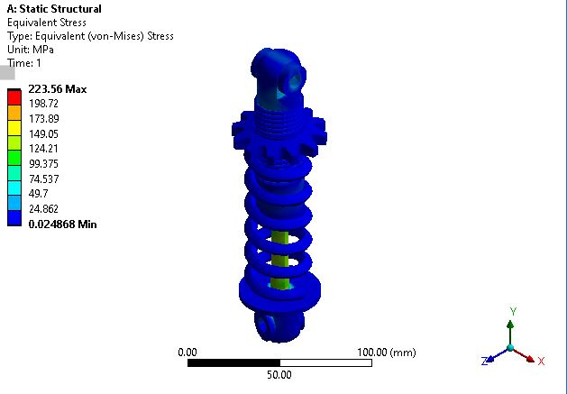
Fig 16: Showing Stress in Steel (Structural)

TECHNICAL PROBLEMS AND SOLUTION
I had to overcome a significant technical challenge during the simulation phase of the shock absorber assembly in ANSYS. I noticed that the mesh quality around the spring coil and threaded nut areas were inconsistent specially in the tightly curved regions. This resulted in unrealistic stress concentrations and uneven deformation in the post-processing results. Initially, I was confused because the deformation and strain values in the spring were fluctuating abnormally which made difficult to judge which material truly performed better. I struggled to understand whether the issue was with the geometry or the simulation setup. I discovered that the default mesh settings were insufficient for capturing the fine details of the helical coil and threads. I did this by discussing the issue with my mentor and reviewing the literature review. Then, I refined the mesh by applying local sizing to the spring and nut areas. After re-running the analysis with these changes, I found more realistic results across all components uniformly.

SUMMARY
The project effectively evaluated the damping capabilities of a shock absorber model under dynamic loading conditions through simulation analysis. Initially, I conducted a comprehensive literature review to determine key design parameters focusing on vibration control efficiency. The literary sources helped to ensure that the selection design profile provided a solid foundation for comparing with these materials. I demonstrated the structural behavior of a shock absorber using three various materials: Aluminum Alloy, Steel (Structural) and Magnesium. The 3D models of base, top rod, spring, and nut were modeled individually in SolidWorks and later assembled with proper mating features for real-world representation. The assembly was then simulated in ANSYS to find out the structural behavior across all the selected materials. The results finalized that steel (structural) had the minimal def. and strain maintaining strength which made it the most suitable material under loading condition.
Through this project, I enhanced my skills in CAD modeling of individual components using SolidWorks and learnt to create effective meshes for complex assemblies by simulation in ANSYS. I tackled challenges like mesh quality optimization and proper boundary condition application through iterative refinement. I also deepened the understanding of how component interaction and material behaviour affect the overall dynamic response of mechanical systems. Additionally, I developed critical problem-solving and communication skills essential for the successful completion of the project.

